# 1.0 Introduction

In this assignment, we are required to build an image enhancer system which can enhance the given set of images so that the images are processed with high quality. The system is required to be written in python programming language and there are several algorithms used to ensure the images look better in terms of quality. The quality of images were measured in terms of the image’s noise, sharpness, color accuracy and so on. Besides that, special effects also were implemented to make sure the images look attractive as well. In addition,  PySimpleGui python library also used to create a simple gui for the system. All the potential problems for developing the system have been identified and the suitable solutions have been proposed by the team.

## 1.1 Objectives

* To study the formation and data of the images
* To determine the algorithm to be used
* To produce appealing and meaningful image result
* To achieve interactive and user-friendly of result presentation

## 1.2 Problem Statements

* **Technique and Algorithm Selection**

Every algorithm has its own strength and weakness when processing diverse types of image data such as grayscale image and RGB image. However, the team does not have any direction on what to process for the images. Therefore, suitable sets of algorithms must be decided for the targeted image dataset to maximize the quality of the result.

* **Image Restoration and Cleaning**

Before any enhancement of the image, the image should be going through restoration and cleaning. To do that, the team needs to first identify the flaws on every particular image including noise, color distortion and brightness issues. The restored image should be cleaned while not influencing the main identity of the images.

* **Image Meaning Representation**

After the images are all nearly completely processed, the team should emphasize or give meanings to the image since some of them cannot stand out any meaning on its own. Hence, the usage of special effects and filters required the team to decide for producing a better image meaning representation.

* **Code Execution**

Since there are not only one single image but a couple images to process, there might be confusion and complexity when executing the code while presenting the result. The team needs to determine a way for presenting all the processed images and possibly a variety of the same image result.

## 1.3 Proposed solution

* **Evaluate and compare the technique and algorithm for the specific image**

To solve the problem of choosing technique and algorithm for image processing, we can test the algorithms collected from researches and findings to evaluate the image from the perspective of brightness, contrast and meaningfulness. After the evaluation, the best algorithm that produced the most satisfied output will be chosen to implement in the image processing system built.

* **Regularization and reconstruction the image restored**

In the image restoration and cleaning, the image may lose its own meaning or shapes after denoising. Therefore, the parameters of the algorithm must be regularized by stabilizing the image to produce an identical observation. Some deep neural network may be used to overshadows that low-resolution image.

* **Adding new component like special effect to increase the meaning of image**

The image meaning representation is highlighted by adding special effect and filter in the image. The image can be added with words that is related to the image to increase the meaning of the image using word instead of just an image. The image filtering can also change the colour tone of the image and increase the visual quality of the image.

* **Simplify and generalized the code collected for the image processing**

Since there are many types of image processing need to be implemented in the code, we have to discuss on the people who coding for the specific image process so that the code may not clash together. It is better for the developers to integrate all the coding together into the system when the image processing system is almost done.

# 2.0 Image processing techniques and algorithms

## 2.1 Overexposed image enhancement (Gan Qian Chao)

Nowadays, people are strongly believe that the digitalization of photography had improved the photo quality through its contrast and brightness parameters tuning manually. However, the light from the environment is hard to remove from the method above and it had affect the information and meaning of the image. Therefore, the overexposed image, which is the image which too much light sources need to be enhanced through its brightness and contrast by implemented the algorithms and approaches given from researches. There are 2 type of methods that had been discovered:

Method 1: High dynamic range algorithm and color correction

In the research on this method, the high dynamic range algorithm is started with converting the RGB color image to HSV format image. It is because HSV format has the information of color portion, saturation and value of brightness from the image. Therefore, we can change the color distribution of the image without affecting the other chromatic information of the image. By using the calculation of exposure factor, the V value which is the brightness value is implemented with Gaussian membership function when the pixel intensity is darker while triangular membership function is used for region that have brighter pixel intensity. The contrast of the image is changed through the implementation of Gaussian membership function to the S value which is the saturation of the image and modify using sigmoid membership function. After that, the image is convert back to RGB format for final result. (Arora, Hanmandlu, Gupta, G., & Singh, 2015)

Method 2: Adaptive inverse hyperbolic tangent algorithm

In the research paper found, the contrast and brightness of the image is identified with the grey level distribution which the histogram is targeted to be high-contrast and stable brightness as the histogram e in Figure 1. Therefore, the α and β parameters, which are the gain (brightness) and bias (contrast) is needed to be set in a set of suitable values by using histogram equalization in adaptive inverse hyperbolic tangent algorithm. The pixel values of the image are redistributed with the normalization values for a higher contrast image. For the overexposed image, the right skewed gray level histogram will be normalized and distributed with an average value among the whole histogram. The HSV format image is used to convert the color space of image. The bias and gain power function are used to determine the range of input pixel value and remap the contrast of the image. (Yu, Ouyang, Wang, & Chang, 2010)

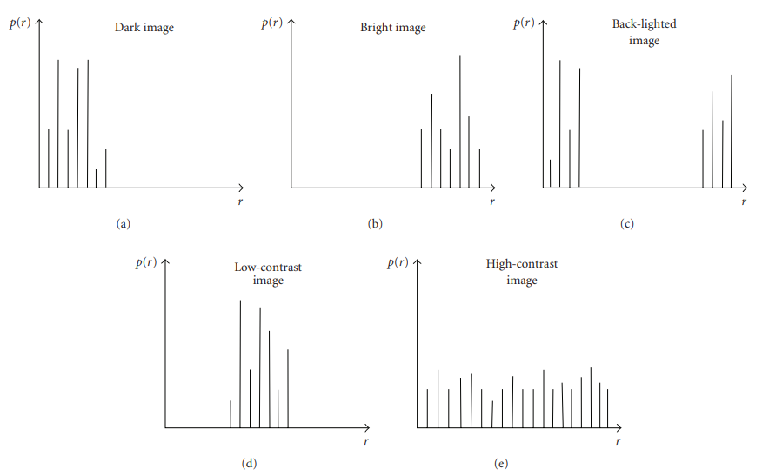

Figure 1: Grey scale distribution of different images

Justification

Through my findings in the researches and other related website on the image enhancement, I think the method 2 is more applicable for the overexposed image enhancement in this assignment. This is because the algorithm provided for this method can be improve in the brightness and contrast more easily than implementation of fuzzification to the image. However, due to the complicated calculation of the bias and gain value in the algorithm, I decided to obtain the values from the histogram equalization which the normalized pixel value of the image will be result to enhance the overexposed image. A similar idea that is similar to this method will be implemented in this assignment for image 3-7.

## 2.2 Image noise reduction (Sia De Long)

Before the decision of algorithm selection decided, a literature review on related works had been done to improve the understanding of image noise reduction on different types of noise. Noise can be existing on an image due to various reason causing many types of them, so image restoration needed to be done to improve or recover the quality and information of an image before further enhancement.

The paper (Youlian & Cheng, 2012) proposed an improved algorithm based on median filtering technique for image noise reduction. Based on the paper research, there are different type of noises and they are all corrupting the image information while affects the image visual effect. Therefore, this paper will be focusing on a nonlinear filter method which is median filter due to its excellent noise-reducing effects. However, the limitations are high time complexity and possibly of image details removed caused by static algorithm. Hence, they improve the algorithm by allow it to adaptively resize the mask according to the noise levels of the mask, while statistical histogram is introduced to significantly reduce the time needed for searching the median value and correlation of image. In the end, a few simulations had done by denoising using image with impulse noise and proved that the problem statements are solved.

The paper (Ruika & Doye, 2010) proposed image denoising technique using wavelet transform. Based on the paper research, noise is often corrupting the image and still a challenging problem to remove them from the original image. Hence, new approach of threshold function developed for image denoising in this paper. It will mainly use wavelet transform algorithm and connect it with threshold functions while comparing with each other including Universal, Visu Shrink, Sure Shrink and Bayes Shrink, normal shrink. After the experimental comparison, the result showing that wavelet shrinkage denoising had proved to be nearly optimal solution for image with gaussian noise. Besides that, Bayes Shrink method produced output which is much closer to high quality image while there is no blur left because of its good performance on denoising multiplicative noise which Visu Shrink cannot achieve. Last but not least, Visu Shrink and Universal threshold functions are weak on denoising salt and pepper noise on images.

The research from journal paper on related works contributes some value findings, including an improved median filtering technique and wavelet transform with different type of threshold functions can be effective on denoising images. The importance of noise type identification is emphasised on both of the paper in the purpose of achieve the effective of noise denoising process. Since there are total 5 images needed to be processed and involved different type of situation that need to be restored, the team decided that different approach will be applied by considering the type of noise on the images to maximize the quality of the result image. Besides that, the algorithms on the researched paper will be utilized during the image restoration process since they are showing a good performance and related to the work.

## 2.3 Dark Image Enhancement (Sharveen Aruljodey)

A literature review has been conducted on two research papers in order to better understand techniques and algorithms used to enhance low light images. Digital low light images often have poor visibility if there isn’t proper lighting and fail to produce visually pleasing outcomes.

The research paper entitled “Low-light Enhancement via Illumination Map Estimation” by (X. Guo, Y. Li and H. Ling, 2017), discussed about using illumination map estimation algorithm enhance the low light images. The main idea of the illumination mapping is about a panoramic image of a surrounding that describes all the light incident at a point. To be more precise, the illumination map will be constructed based on each pixel ‘s maximum red, green and blue channels, then (Augmented Lagrangian Multiplier) ALM algorithm used to refine the illumination map produced. Gamma correction is then used to denoise the image and followed by BM3D for block matching. The images below show the example of sets of images used and its results.

Figure 2: First row: low light images used.

Second row: images produced with illumination map estimation. Third row: The output produced

On the other hand, the research paper entitled “Night-time low illumination image enhancement with single image using bright/dark channel prior” by (Shi, 2018), discussed about using dual channel prior-based method for low light image enhancement. There are 7 major steps include in the algorithm which are getting the bright and dark channel prior, computing the global atmosphere lighting value, figuring out initial transmission map, estimating corrected transmission map by using dark channel, using guided filter for smoothing and finally calculating the resultant image. The term channel prior is just referring to the maximum and minimum pixel values of the original image. Once the bright and dark channel prior is obtained then, the atmospheric lighting will be calculated by slicing the top 10 percent of bright channel prior pixel and getting the mean of it as shown below.

Figure 3: compute global atmosphere lighting

Later, transmission map is formed using the bright channel value and compared with dark channel value to produce a corrected transmission map. Finally, the image will be filtered using guided filter to smoothen the transmission map and resulting the enhanced image. The figure below shows the flowchart of how dual channel prior based method works.

.

Figure 4: Dual channel prior based framework

Based on the literature review done above, the dual channel prior based algorithm is chosen as other processing techniques such as histogram equalization-based methods, wavelet transform based method and retinex-based method such as illumination map estimation might result to image with over contrast enhancement or noise amplifications.

# 3.0 Image processing algorithms application

## 3.3 Image 3 (g.png) processing

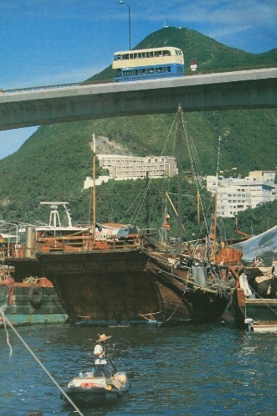

Figure 5: Image 3(g.png)

The image 3 is found to have a dull color tone. Therefore, we decided to implement color tone enhancement by changing the HSV value of the image. The image is aimed to have different color background, higher saturation and brighter tone. Therefore, there are few step need to be implemented:

1. Convert image to HSV type image

2. Increase the hue value between 0 to 180 to change the color of the image

3. Increase the saturation value to get a higher saturation color

4. Increase the color value to increase the brightness of the image

5. Convert image back to BGR type

Since the image is suitable for making enhancement from mirroring the image side by side to get a more meaningful image. Therefore, we implemented the mirroring algorithm the image as below:

1. Convert image to RGB type

2. Use ImageOps mirror function to create mirrored image

3. Create a background that is double the width and same height with the image

4. Place the original and mirror image side by side.

The sides effects like adding text and masked image into the image are implemented which will be shown during the presenting of solution.

## 3.4 Image 4 (3-7.jpg) processing



Figure 6: Image 4 (3-7.jpg)

The image 4 is found to be too overexposed as the high brightness had reduce the meaning of the image. Therefore, the implementation of method which changing the brightness and contrast using α and β parameters, gain (brightness) and bias (contrast), is done for optimizing the brightness and contrast of the image. First of all, the calculation of α and β parameters is needed to ensure the optimize value of the parameters with the histogram equalization of the image. (Stack Overflow, 2020) The step of the calculation is shown as below:

1. Convert image to grayscale type

2. Create a grayscale histogram for the overexposed image

3. Calculate the cumulative distribution from the histogram

4. Locate the maximum point, minimum point, left cut and right cut of the equalized histogram

5. Calculate the alpha and beta value using the maximum and minimum value of normalized histogram with the formula:

α = 255/ (max value – min value)

β = - (min value) * α

6. Display the histogram to show that the difference between original and normalized histograms.

The figure below had shown the original histogram (blue) is right skewed as more of the pixel in image have high pixel value while the normalized histogram (orange) had reduce the unbalance histogram by the desire range between maximum and minimum value of obtained from the calculation.

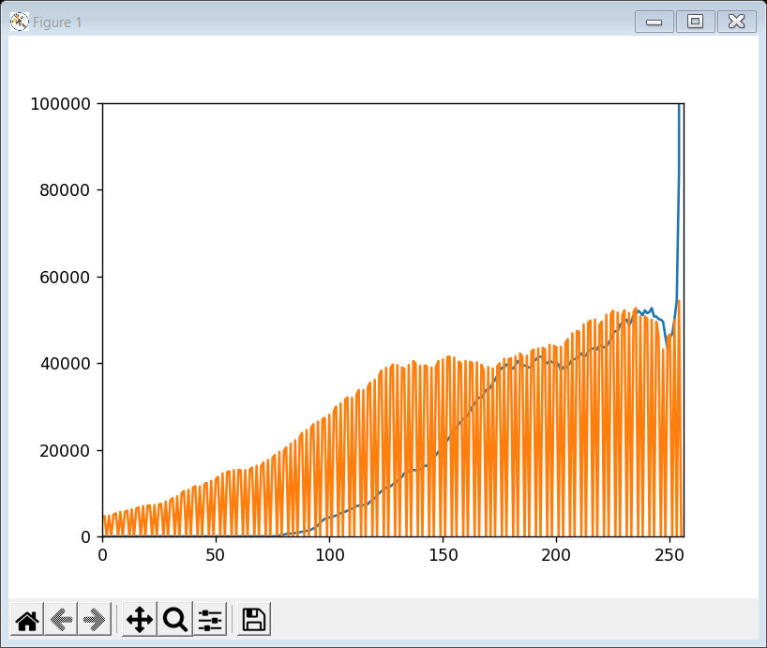

Figure 7: Histograms of original and normalized image

7. According to the alpha and beta value calculated, the new gain and bias value of the image is convert to scale type which is 8 bit to produce the absolute value of image in the enhanced image.

The sides effects like adding text into the image are implemented which will be shown during the presenting of solution.

## 3.5 Image 5 (017.jpg) processing

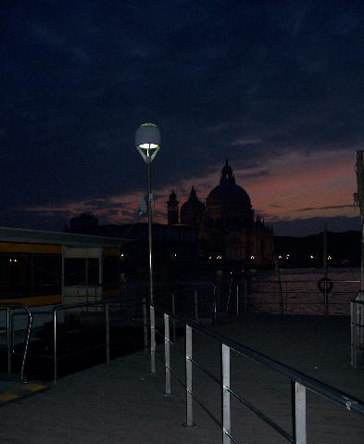

Figure 8: Low light image used (017.jpg)

The image above has a dark and low light environment. Therefore, we have decided to implement dual channel prior-based method for the image enhancement. Although there are many techniques used such as histogram equalization-based methods and wavelet transform based method, dual channel prior based method suitable as we have only single image to enhance, and the other techniques might cause over contrast enhance or noise amplifications. The image is aimed to have better visibility and brighter tone. The steps implemented for this process are: -

1. Obtain the bright and dark channel prior (max and min pixel intensity of image)
2. Computing the global atmosphere lighting using max pixel intensity
3. Diagram

   Description automatically generatedFind initial transmission map (portion of light that not scattered with the formula below.)
4. Correcting the transmission map using dark channel
5. Smoothing the transmission map with guided filter
6. Calculate resultant image and create function to combine all the output found in step 1 till 5 and apply to the image.

# 4.0 Screenshot of the solution

## 4.3 Image 3 (g.png)

1. In the main page of the image enhancer, click the Image 3 button to direct to the Image 3 page

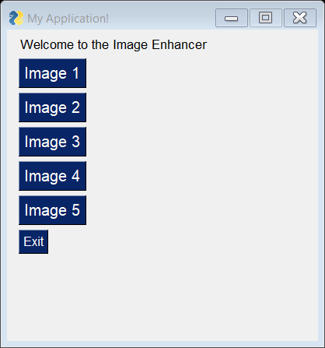

Figure 9: Main Menu Page

2. Click on Load Image button to load the image 3 in the output.

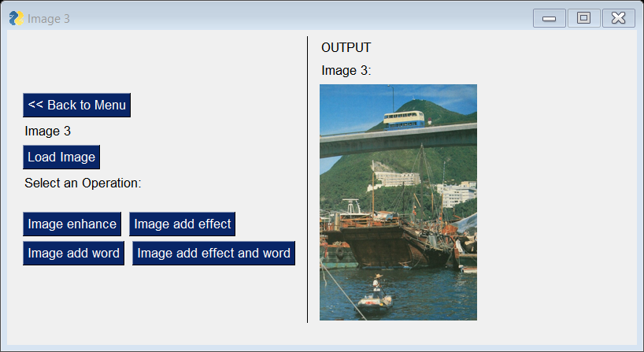

Figure 10: Image 3 page with load image function

3. Click on Image enhance button to add mirror effect and color tone change in image 3.

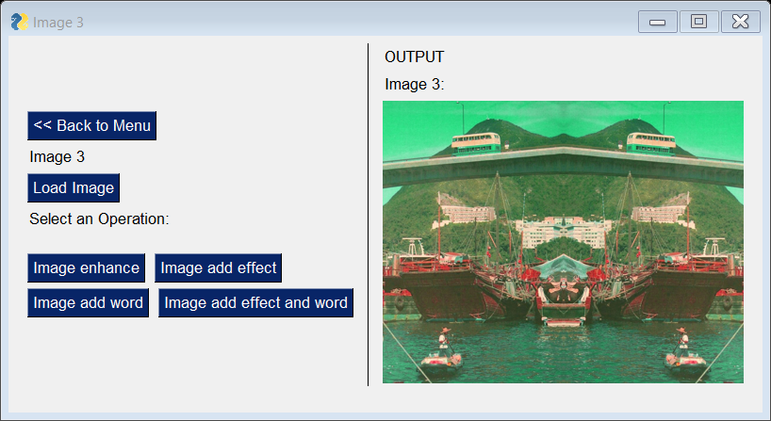

Figure 11: Image 3 page with image enhance function

4. Click the Image add effect button to add boat effect at the right bellow corner to the enhanced image.

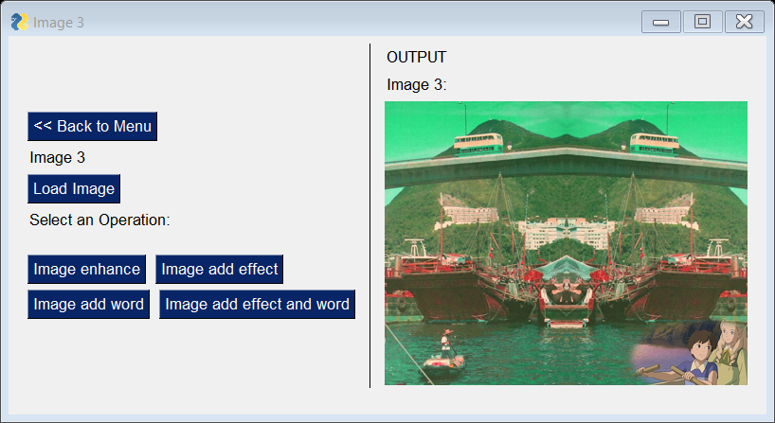

Figure 12: Image 3 page with add effect function

5. Click on the Image add word to add word to the middle of the enhanced image.

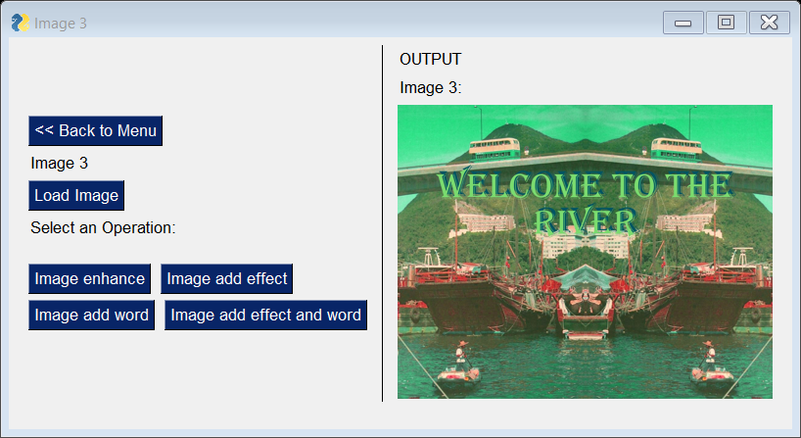

Figure 13: Image 3 page with add word function

6. Click on the Image add effect and word button to add both boat effect and word to the enhanced image.

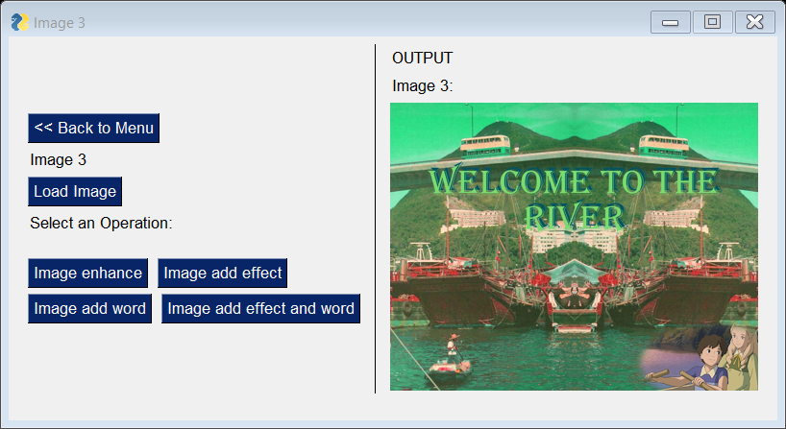

Figure 14: Image 3 page with add effect and word function

7. Click on Back to Menu button to redirect back to the main page.

### 4.3.1 Screenshot of coding (Image 3)

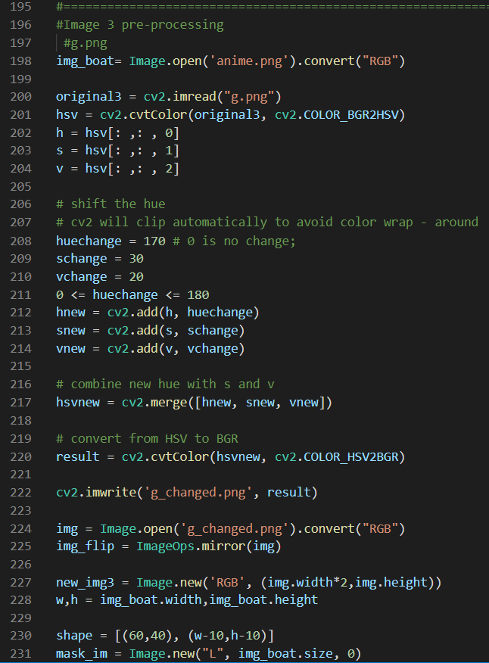

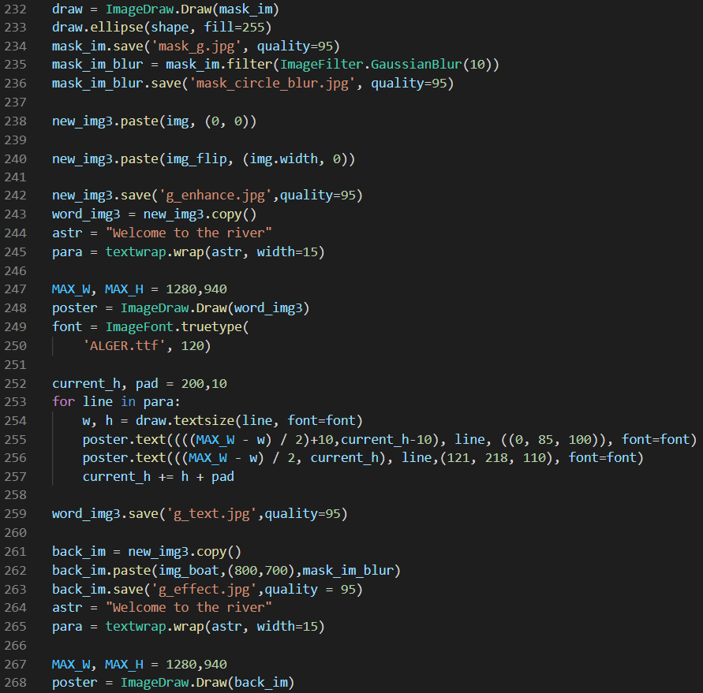

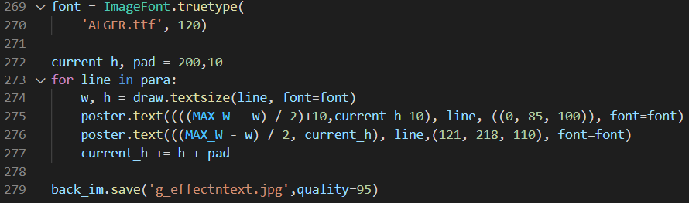

Figure 15: Coding Implemented for image enhancement of image 3

To change the HSV value of image 3, the image is converted to HSV mode with changing the H, S, V value of the image. The code in line 201 – 220 had shown the process mentioned had change the HSV value using cv2 and change back to BGR mode. In the line 224 – 228, the mirror effect is added to put side by side of new and old image to show an adjacent image. An blur oval mask with the image of the boat is added using ImageDraw function in line 230-236. To insert words in lines, the textwrap function is called with ImageDraw to make the text to be written in the textwrap of image in line 243-259. In line 261 – 263, The masked boat image is added into the image. For adding both text and effect, the coding of adding text is used again with the combining of image with effect to produce an image with text and side effect.

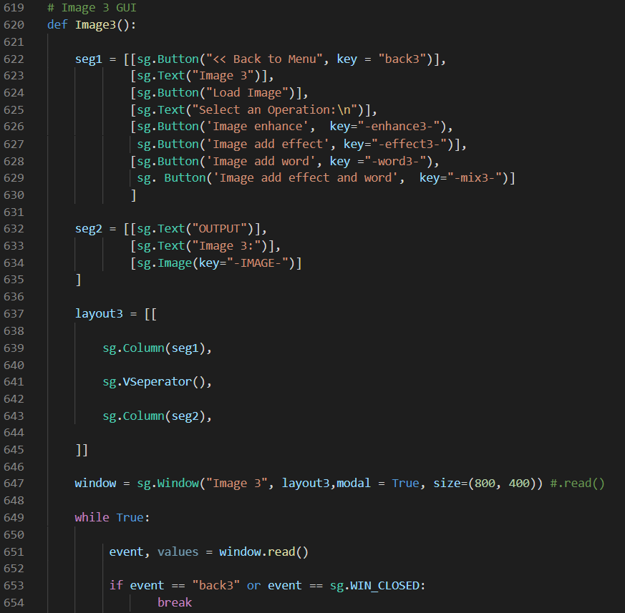

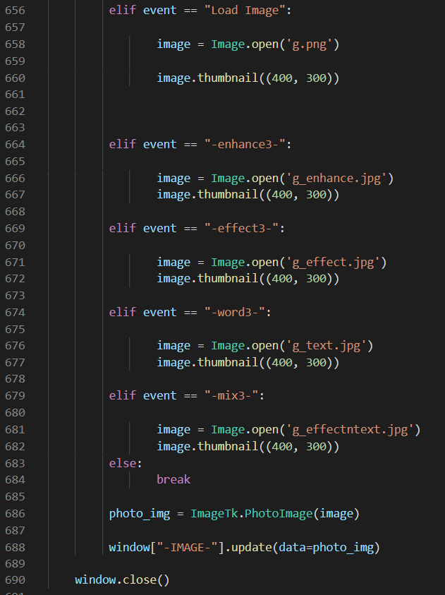

Figure 16: coding of GUI of Image 3

## 4.4 Image 4 (3-7.jpg)

1. In the main page of the image enhancer, click the Image 3 button to direct to the Image 4 page.



Figure 17: Main menu Page

2. Click on Load Image button to load the image 4 in the output.

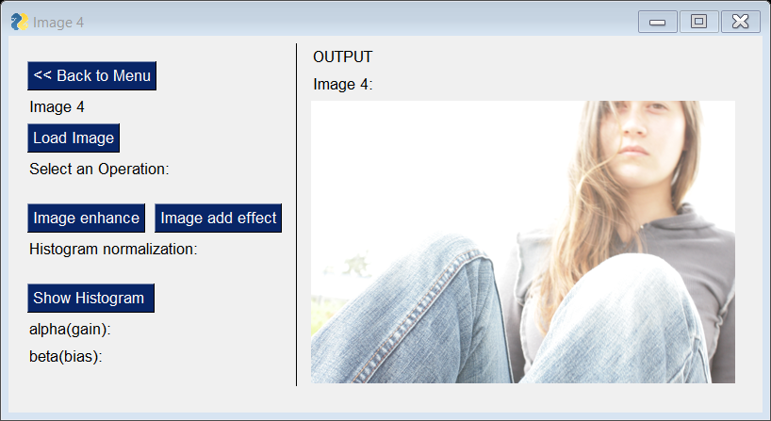

Figure 18: Image 4 page with load image function

3. Click on Image enhance button to enhance the image 4 to be less exposed to the light.

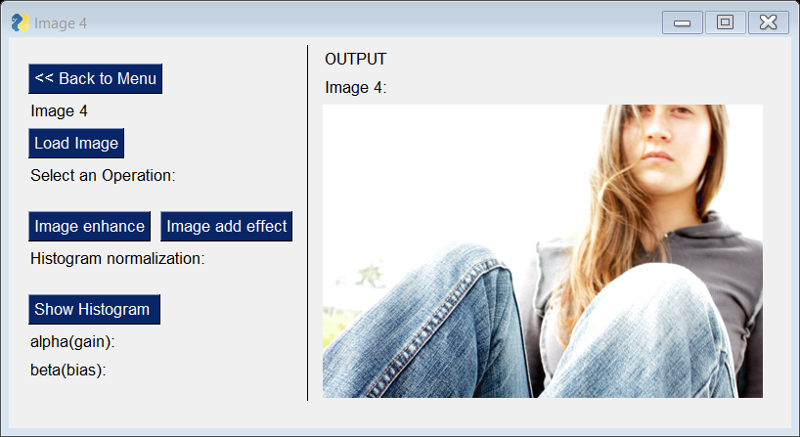

Figure 19: Image 4 page with image enhance function

4. Click on the Image add effect button to add effect like word in the enhanced image.

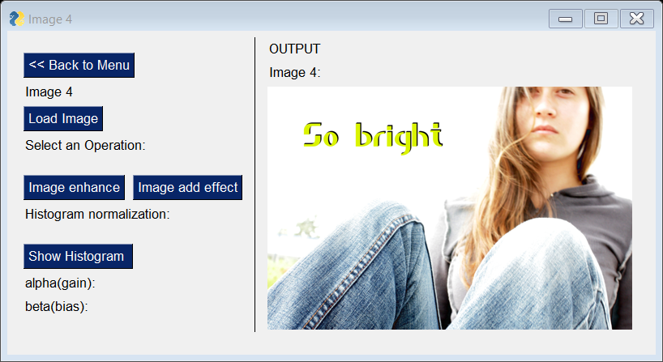

Figure 20: Image 4 page with image add effect function

5. To show the histogram for proving the histogram of old image and enhanced image with the alpha (gain) and beta (bias) values of the image, click on the Show Histogram button to view the histogram and the values needed in the interface.

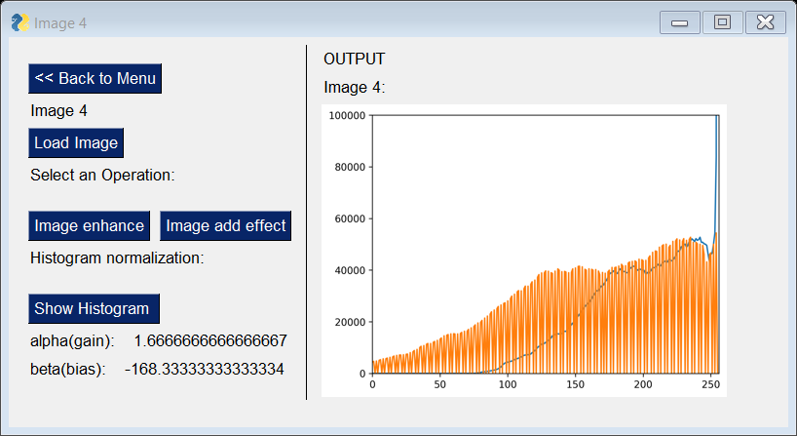

Figure 21: Image 4 page with show histogram function

6. Click on Back to Menu button to redirect back to the main page.

### 4.4.1 Screenshot of coding (Image 4)

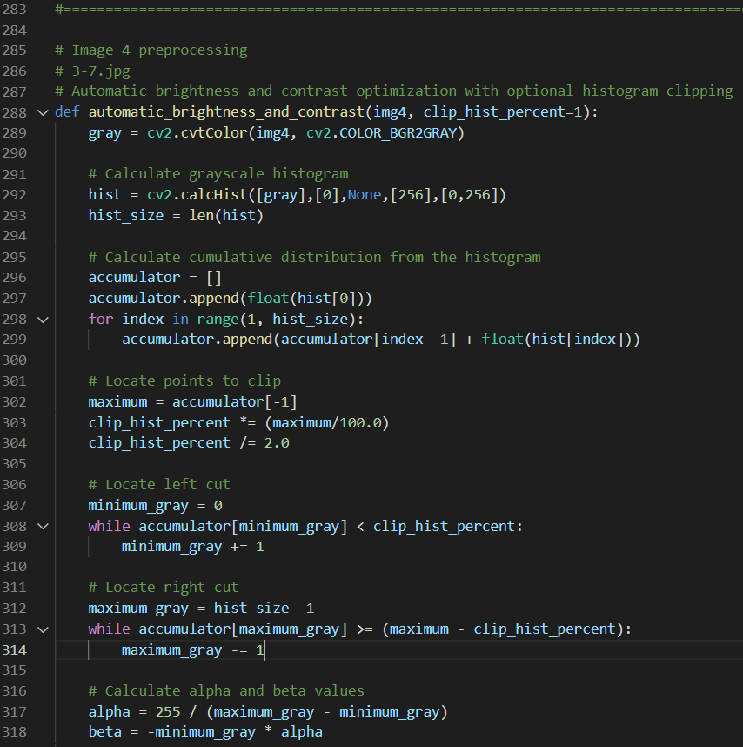

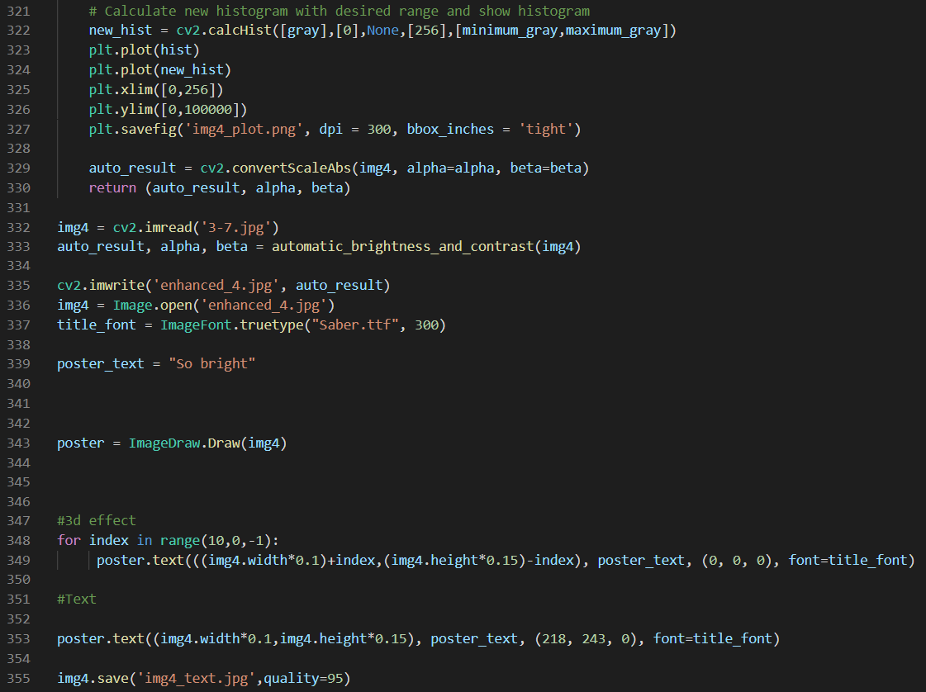

Figure 22: Coding Implemented for image enhancement of image 4

First, the image 4 is converted into grayscale mode in line 289. The coding in line 291-293 had provide a grayscale histogram of the original image. In the line 295 – 318, the calculation on the cumulative distribution of the histogram for finding the value of maximum and minimum gray value, alpha and beta value of the image. To produce a histogram of comparison between grayscale value of original and enhanced image, the plotting of histogram is done using matplolib library in line 321-327. In line 332 – 333, the alpha and beta value is implemented into the image for equalizing the brightness of the image. To add 3d effect into the image, the ImageFont function is used to add text into the enhanced image in line 335-355.

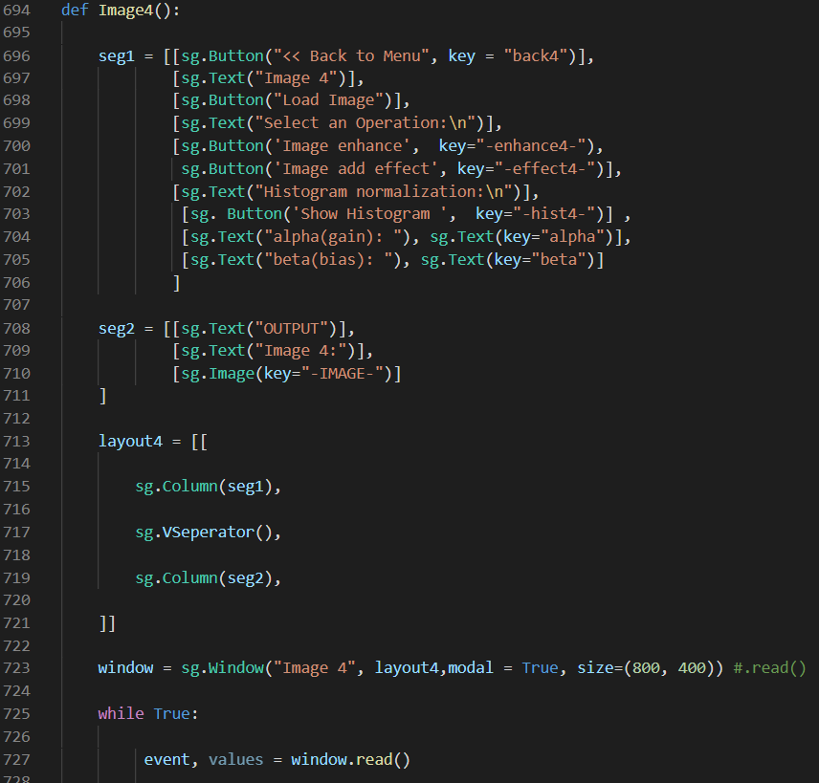

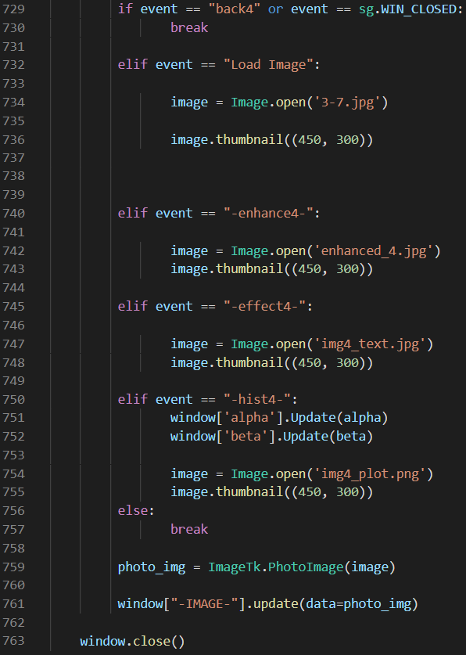

Figure 23: coding of GUI of Image 4

## 4.5 Image 5 (017.jpg)

1. From the main menu shown below, button “Image 5” will be directed to next section where low light image enhancement will take place

Figure 24: Main Menu

2. “Load Image” and “Original Image” buttons will show the low light image before enhancement.

Figure 25; Low light image enhancement

3. Once button “Corrected Transmission Map” clicked, image with over exposure will be produced before applying the filter.

Figure 26: Corrected transmission image

4. “Guided filter” button will show up the enhanced image as shown in the figure 8 below.

Figure 27: Enhanced Image

5. Button “Add text” will add text to the enhanced image as shown at below.

Figure 28: Text added to image

6. Moon image will be added to the image after “Add Image” button is clicked.

Figure 29: Image added to the enhanced image

### 4.5.1 Screenshot of coding (Image 5)

Step 1: Obtaining bright and dark channel values

Figure 30: Obtaining the bright and dark channel value

Two python libraries that are used for low light image enhancement are cv2 and NumPy. In order to obtain the bright channel and dark channel value a function called “get_illumination_channel” is created. The dimension of the image are stored as M and N variables. Then “np.pad” command were used to pad the image size to make sure they remain same. Then dark channel value is obtained using “np.min()” which will return the lowest pixel value of the image. Meanwhile, “np.max()” command is used to get the maximum pixel value. Then both the bright and dark pixel value returned to be used for next function as shown in the figure above

Step 2: Calculating the atmospheric lighting

Figure 31: Calculate atmospheric lighting value

To calculate the atmospheric lighting value, the image array will be reshaped and flattened with the command “I.reshape(M*N,3)” and “brightChannel.ravel()”. Then sorting and slicing method applied to slice only top 10 of the pixel of bright channel and find the mean of it which is equal to the atmospheric lighting value. “np.mean” is the command used to calculate the mean. Then the mean value is returned to be used for other functions.

Step 3: Finding the initial transmission map using bright channel prior.

Figure 32: Finding initial transmission map

Transmission map meaning the portion of light that was not scattered and reaches the lenses.The transmission map will be calculated according to the algorithm below. *I*bright represent the bright channel value and Ac means the maximum value of atmospheric light.

Figure 33: Atmospheric light estimation formula

Step 4: Estimating the corrected Transmission map by using the dark channel

Figure 34: Corrected Transmission Map

Just like step 3, the algorithm is repeated by replacing the bright channel value with the dark channel so that potential transmission estimation error could be detected. The initial transmission estimation value produced in step 3 will be deducted with the new transmission estimation value of dark channel. Then the corrected transmission map value is returned.

Step 5: Guided filter used to smoothen the transmission map

Figure 35: Guided filter

Guided filter is used to edge preserving smoothing on the image. The command “np. ones()” used to created new array from the given shape which is in our case is declared as “M” and “N”. Then each channel is filtered in the mean filter.

Figure 36: Calculating the resultant image

The grayscale refined transmission map is converted to grayscale image by duplicating the channel of 2D refined map to 3 channels. The command “np. broadcast_to” used to broadcast the array to a new shape. Then the image is max-min normalized with the command np.min() and np.max().

Step 7: Combines all functions and apply it as an image

Figure 37: Combine all functions

The function dehaze () created to combine all the techniques have done earlier and pass them as an image. All the functions created in the previous steps used then cv2.detailEnhance command used to sharpen the images but however it still induces some noise. Therefore, cv2.edgePreservingFilter() used to limit the noise so that the image is fairly better.

# 5.0 Conclusion

References

Arora, S., Hanmandlu, M., Gupta, G., & Singh, L. (2015). Enhancement of overexposed color images. *3rd International Conference on Information and Communicatiob Technology (ICoICT)*, 207-211.

Qing Zhang, Y. N.-S. (2019). Dual Illumination Estimation for Robust Exposure Correction. 243-252.

Ruika, S., & Doye, D. (2010). Image Denoising Using Wavelet Transform. *International Conference on Mechanical and Electrical Technology*, 509-515.

Shi, Z. &. (2018). Nighttime low illumination image enhancement with single image using bright/dark channel prior. *EURASIP Journal on Image and Video Processing*.

Stack Overflow. (2020). *Automatic contrast and brightness adjustment of a color photo of a sheet of paper with OpenCV*. Retrieved from Stack Overflow: https://stackoverflow.com/questions/56905592/automatic-contrast-and-brightness-adjustment-of-a-color-photo-of-a-sheet-of-pape/57116646

X. Guo, Y. Li and H. Ling. (2017). LIME: Low-Light Image Enhancement via Illumination Map Estimation. *Transactions on Image Processing*, 982-993.

Youlian, Z., & Cheng, H. (2012). An improved median filtering algorithm for image noise reduction. *Physics Procedia*, 609-616.

Yu, C. Y., Ouyang, Y. C., Wang, C. M., & Chang, C. I. (2010). Adaptive inverse hyperbolic tangent algorithm for dynamic contrast adjustment in displaying scenes. *EURASHIP Journal on Advances in Signal Processing*, 1-20.

Workload Matrix

|  |  |  |  |  |  |  |
| --- | --- | --- | --- | --- | --- | --- |
| Name  Task | | Gan Qian Chao  (TP055444) | | Sharveen Aruljodey  (TP055927) | | Sia De Long  (TP055766) |
| Introduction:  -Introduction  -Objectives -Problem statement  -Proposed solution | | - Proposed solution | | -Introduction  -Objective | | -Problem Statement |
| Image processing and technique (literature) | | - Over-exposed image enhancement | | - Dark Image Enhancement | | - Image noise reduction |
| Image processing algorithm (application) | | -Image 3  -Image 4 | | -Image 5 | | -Image 1  -Image 2 |
| Screenshot of coding | | -Image 3  -Image 4 | | -Image 5 | | -Image 1  -Image 2 |
| Conclusion | | - | | -Conclusion | | - |
| Coding Implementation | | | | | | |
| Image enhancement | -Image 3  -Image 4 | | -Image 5 | | -Image 1  -Image 2 | |
| Image enhancer GUI | -GUI coding | | -GUI coding | | - | |
| Signature | GAN | |  | |  | |